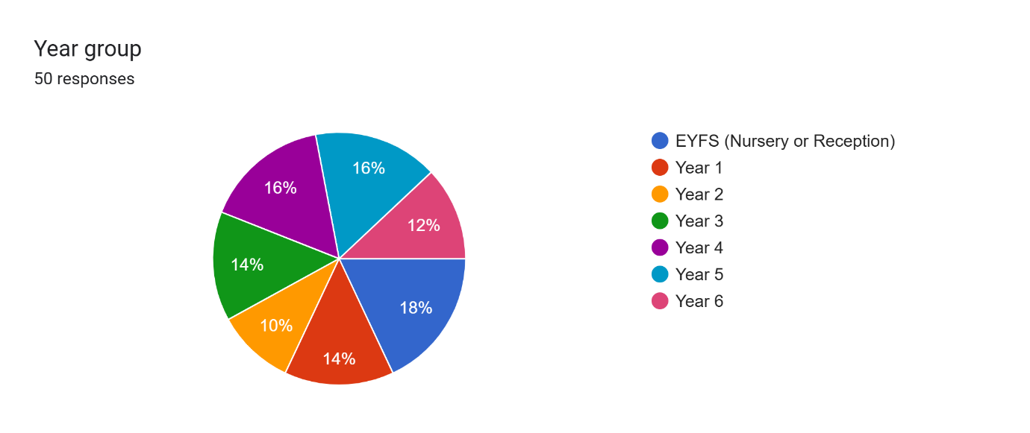
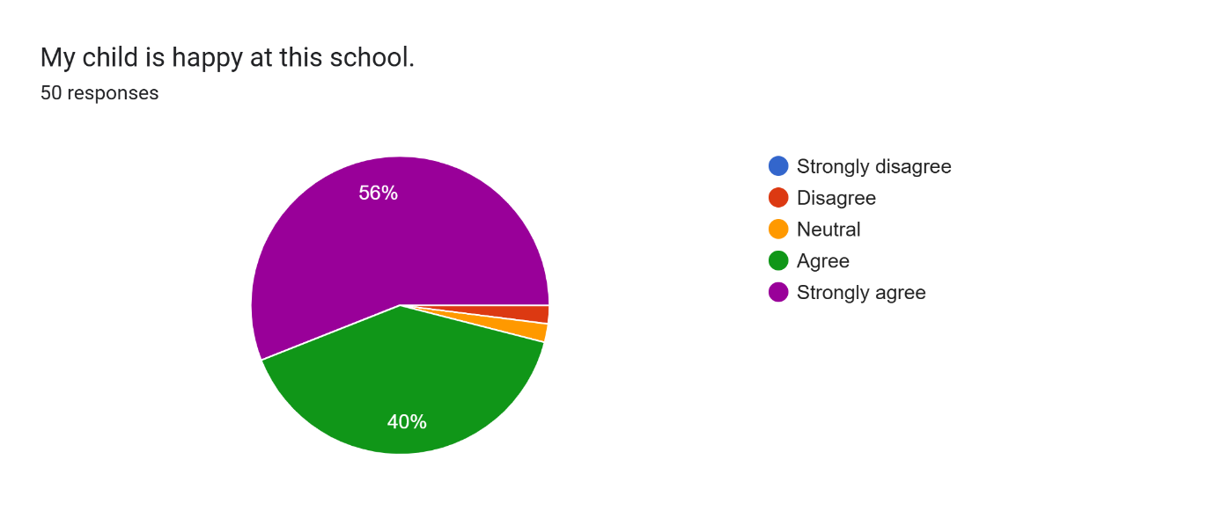
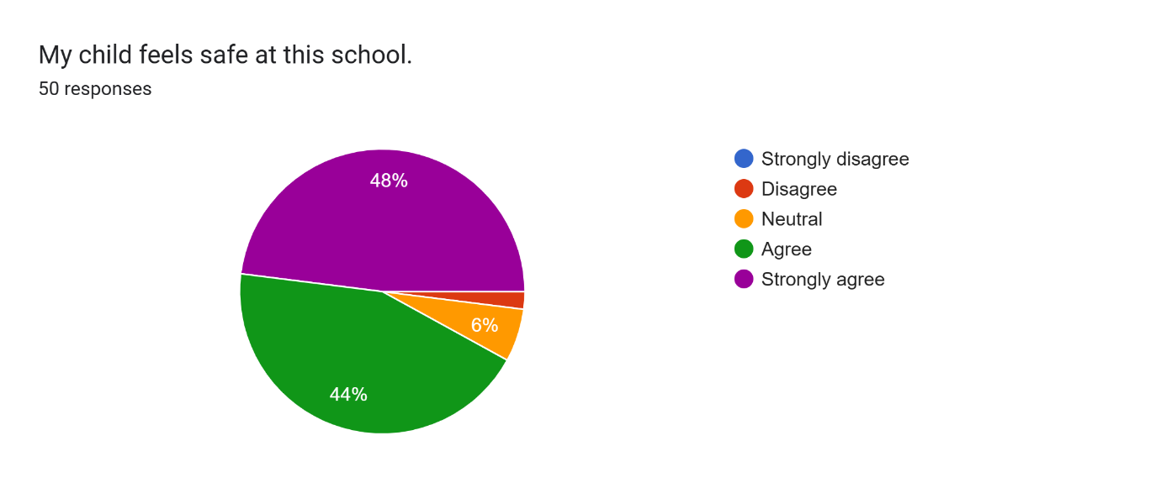
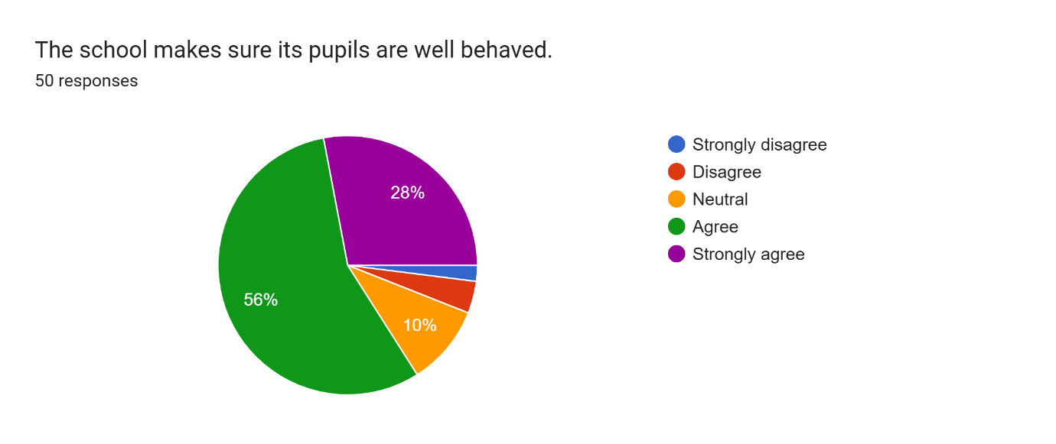
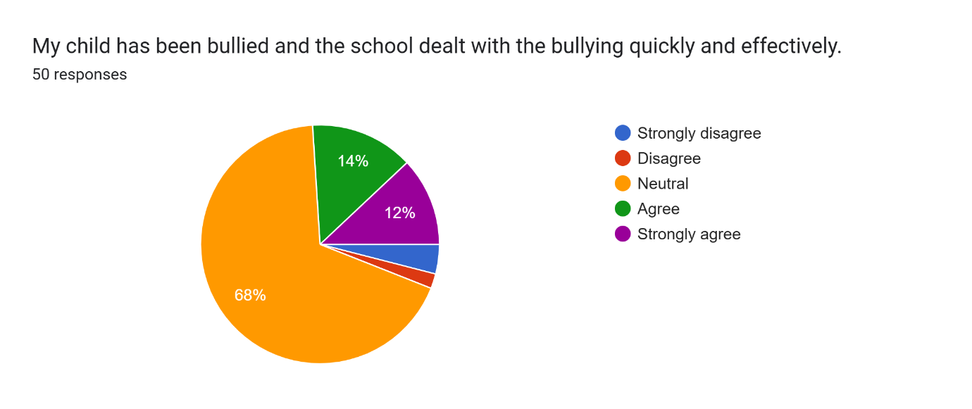
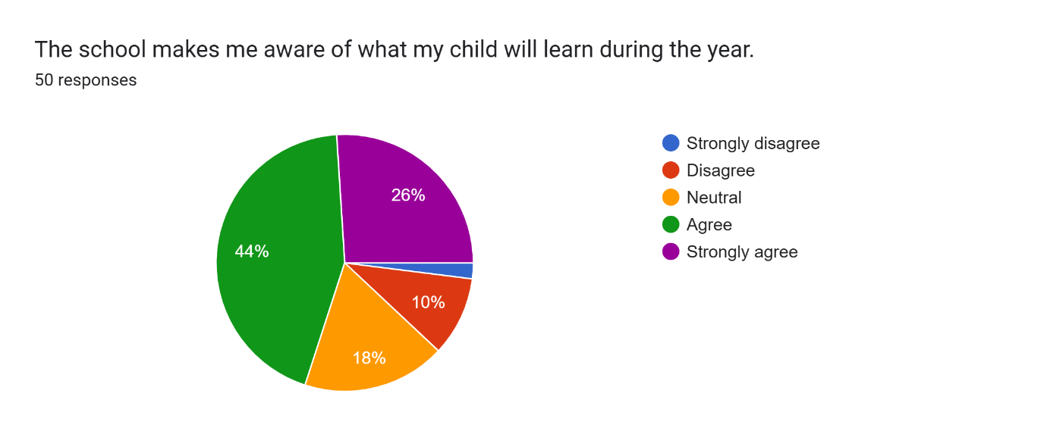
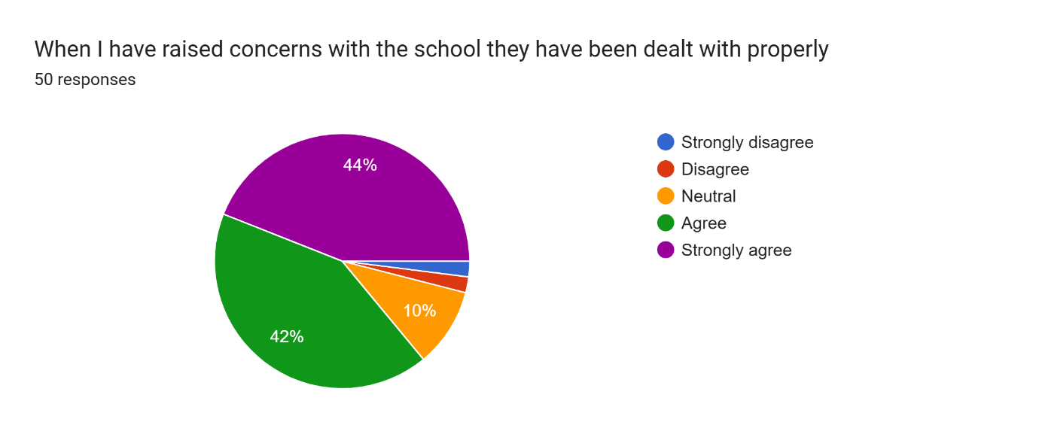
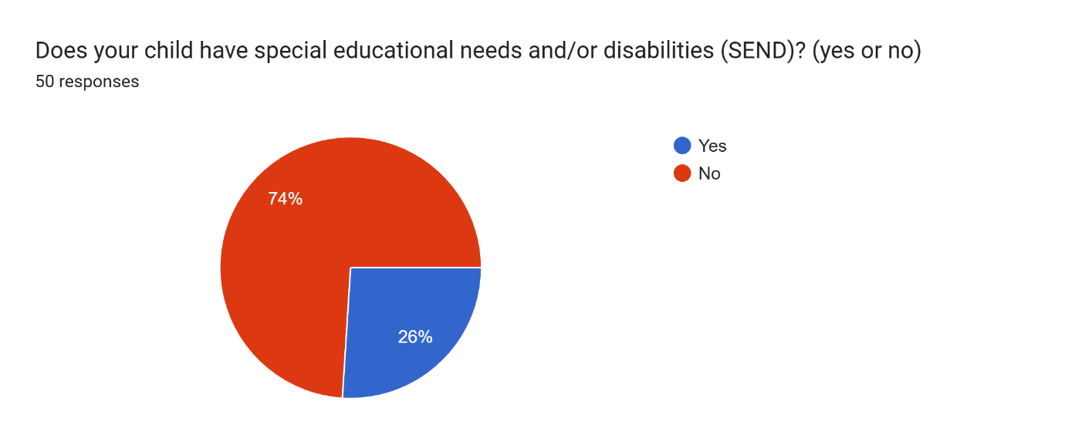
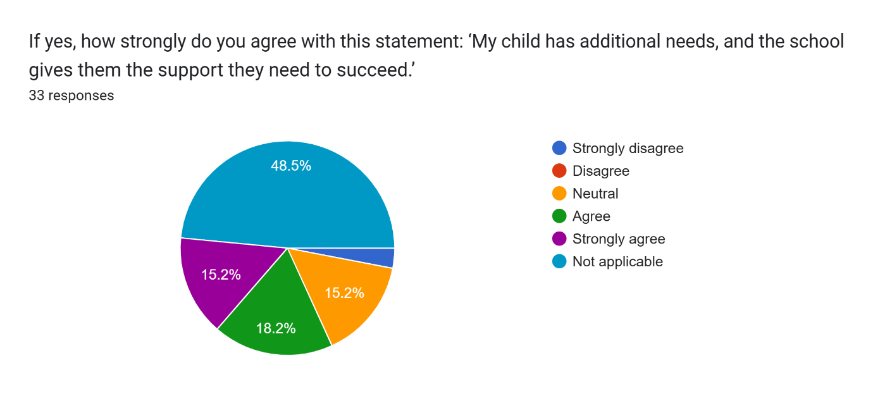
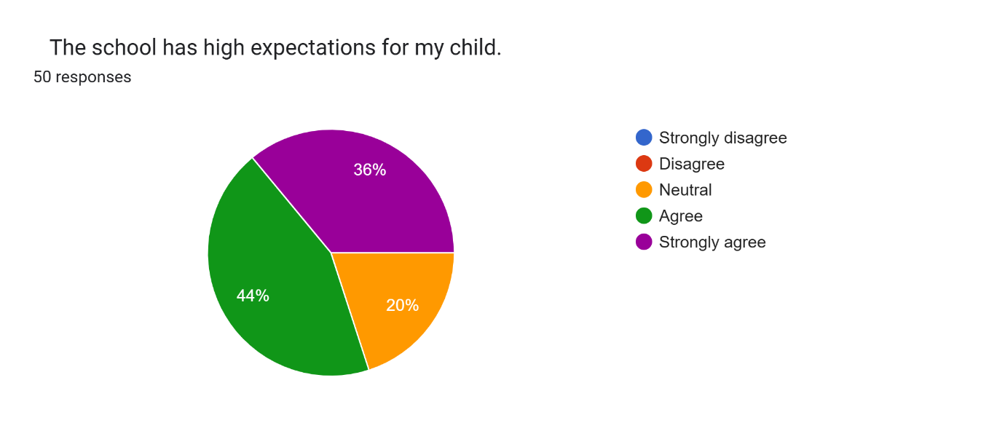
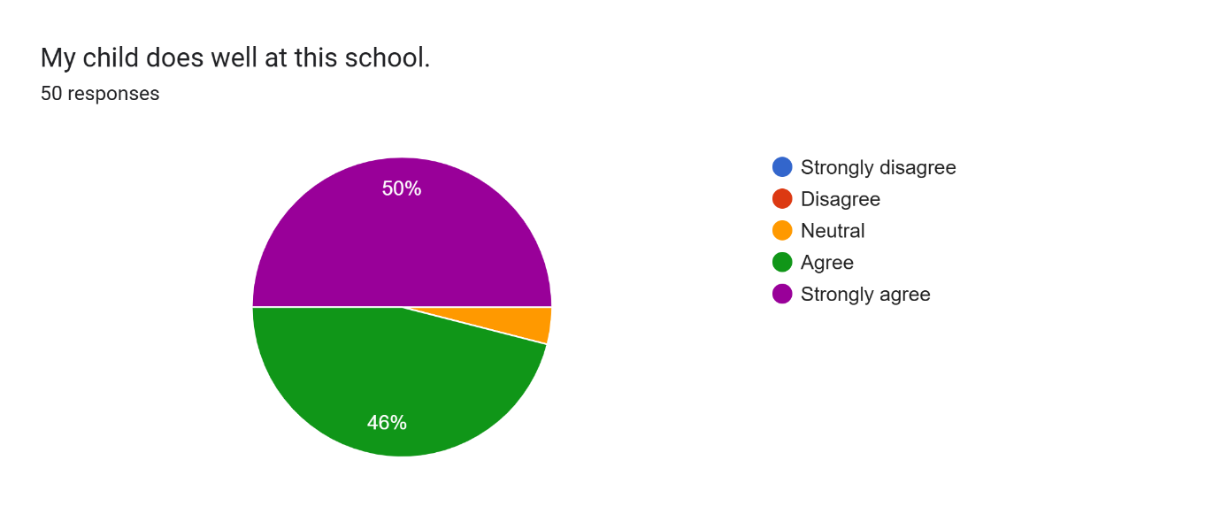
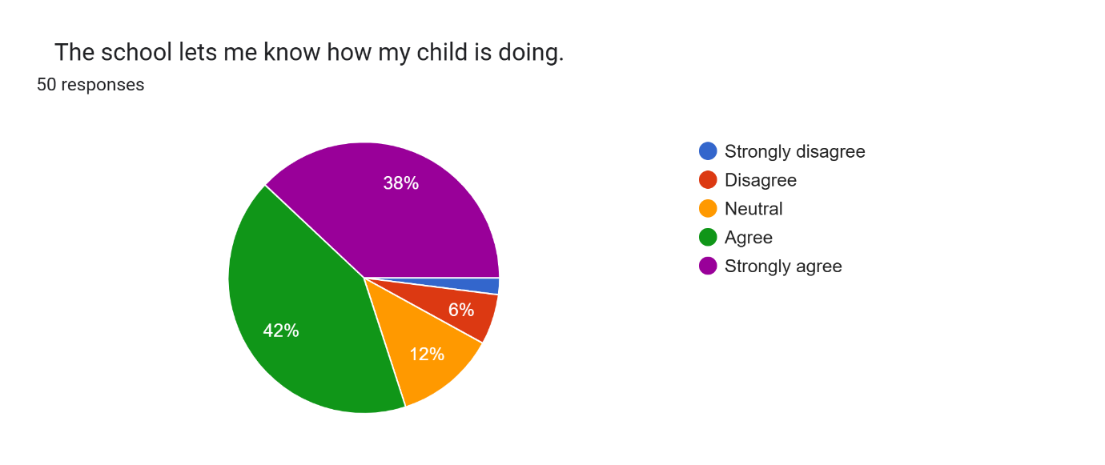
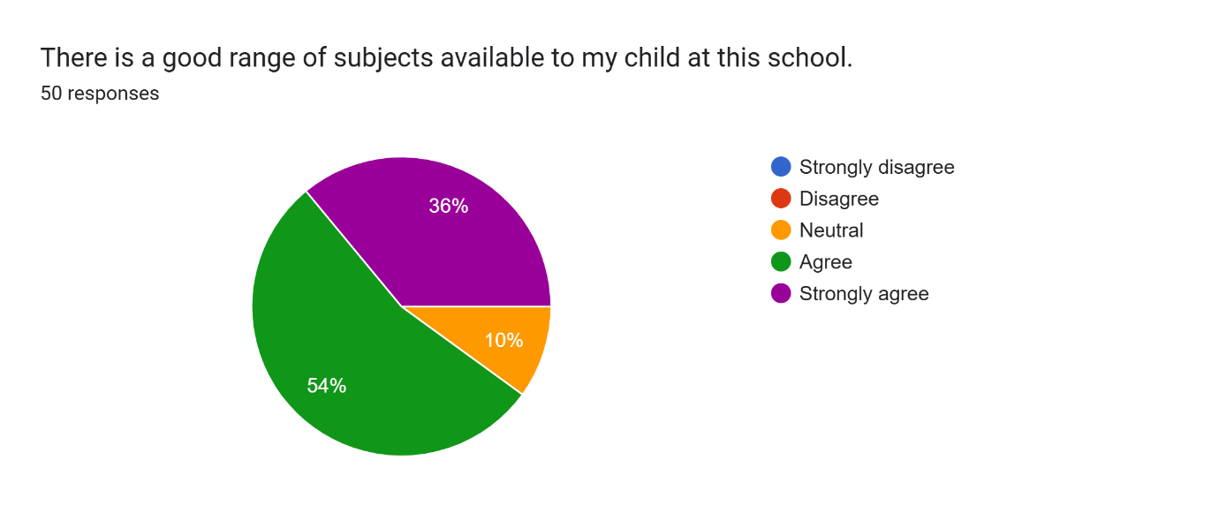
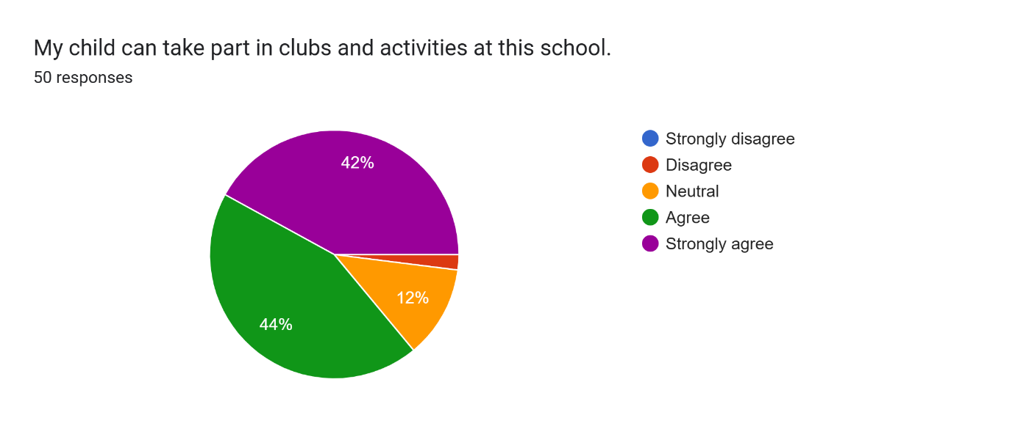
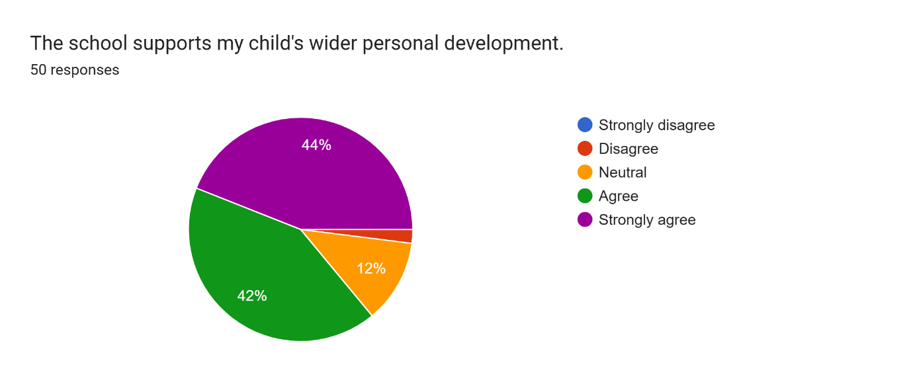
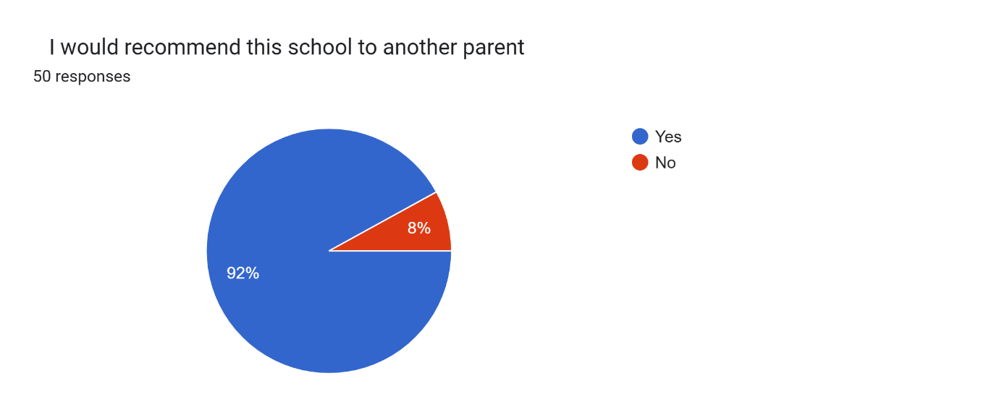
Everything costs
More different types of afterschool clubs would be great, many other schools do this. There is currently only choir or the youth club. PE doesn’t go ahead often due to work from other lessons not being completed, PE is great for mental health. We used to get termly newsletters that give us an idea of what the children were going to learn that term, nothing this year. Not much on updates of how the children are doing individually (the weekly FB posts are great about each class), other schools send out monthly reports or monthly calls about individual learners
My child finds it very difficult to catch up at first but with time his performance increased all thanks to his teachers.
The teachers at Plains Farm Academy are so professional and dedicated to their duties, compassionate and caring. I will recommend the school any time, any day.
The teachers are amazing. And my son loves them and always excited to go school. Even during holiday.
Feedback assessment from the teachers not only on sessional report is very key
My child (whom is autistic) has suffered bullying now for a while and nothing has been done, instead been punished by having to come into school late and picked up early incase the bullying child's parents cause trouble in school yard (can see where thier kid gets it from). Been brushed under the carpet and forgot about, was told police had been informed but 2weeks later police havnt been inotouch yet certain parents ringing on private number threatening us

