Plains Farm Academy
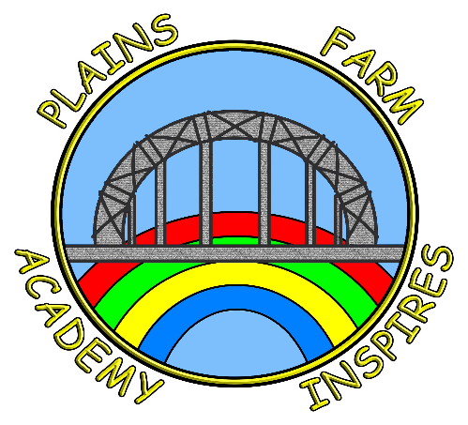
School Performance 2023-2025 - Unvalidated

Key Stage 2 |  | Reading | Writing | Maths
Average progress scores in reading, writing and maths | 2025
Average progress scores in reading, writing and maths | 2024
Average progress scores in reading, writing and maths | 2023 | -2.7 | -2.0 | -3.3

Key Stage 2 |  | Reading | Writing | Maths
Average scaled scores in reading and maths | 2025 | 106 | N/A | 105
Average scaled scores in reading and maths | 2024 | 105 | N/A | 103
Average scaled scores in reading and maths | 2023 | 101 | N/A | 100

Key Stage 2 |  | Reading | Writing | Maths | RWM Combined
Percentage of pupils who achieved the expected standard or above in reading, writing and maths | 2025 | 74% | 70% | 65% | 65%
 | 2024 | 75% | 71% | 71% | 68%
 | 2023 | 69% | 69% | 69% | 59%
Percentage of pupils who achieved a high level of attainment in reading, writing and maths | 2025 | 22% | 13% | 30% | 9%
 | 2024 | 18% | 7% | 18% | 7%
 | 2023 | 10% | 10% | 7% | 7%

Multiplication Check Year 4 |  | 25 | 21+ | 18+
 | 2025 | 21% | 50% | 67%
 | 2024 | 8% | 21% | 71%
 | 2023 | 19% | 52% | 57%

Phonics Screening Check |  | Year 1
Percentage of pupils who achieved the expected standard (32/40) | 2025 | 65% | Year 2 Phonics Resit | 71%
 | 2024 | 74% | Year 2 Phonics Resit | 45%
 | 2023 | 60% | Year 2 Phonics Resit

Early Years Foundation Stage |  | Good Level of Development (GLD)
Percentage of pupils who achieved the good level of development (GLD) | 2025 | 58%
 | 2024 | 50%
 | 2023 | 61%

